**CIS 436**

**Professor John Baugh**

**25 April 2023**

**PokeInfo**

**Ali Hazime**

**Fatima Kourani**

**Zachary Faybik**

**Project Description**

PokeInfo is an application that allows users to select a Pokemon of their choice from over 900 Pokemon. It includes features such as:

* Selecting a Pokemon
* Getting Pokemon Type
* Getting Pokemon Description
* Getting a Pokemon Picture
* An interactable switch button allowing users to view their Pokemon in its shiny form
* An interactable button allowing users to get a Pokemon’s moveset

**Fragments Used:**

* Main Fragment
* Info Fragment
* View Model + Fragment

**Widgets Used:**

* Switch
* Spinner
* Button

**Views Used:**

* Textview for type
* Textview for description
* Textview for Movesets

**Web service Interaction Used:**

* <https://pokeapi.co/>
* https://pokeapi.co/api/v2/pokemon?limit=905

**Key Screenshots:**

**Info Fragment XML**

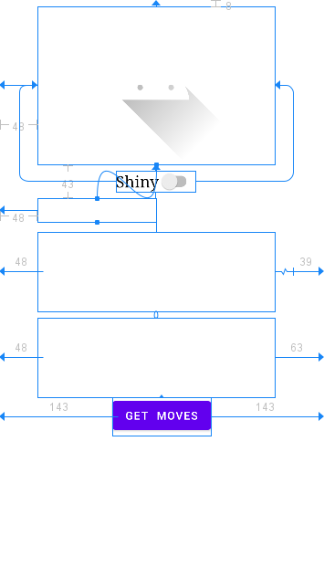

**Main Fragment XML**



**Main Activity XML**

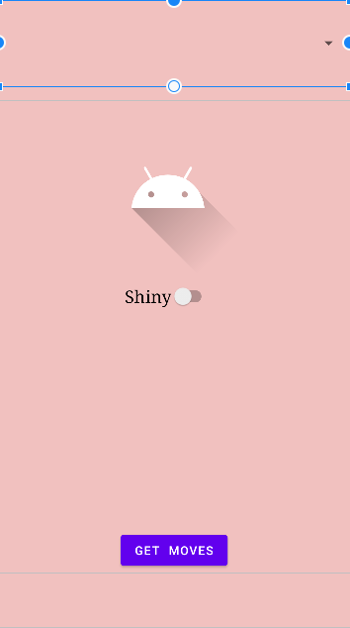

**Startup Application**

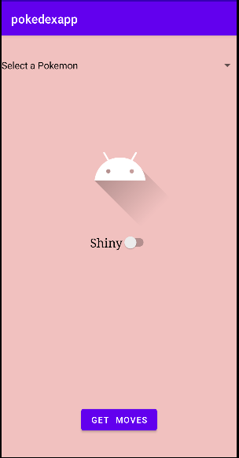

**Pokemon Selected**

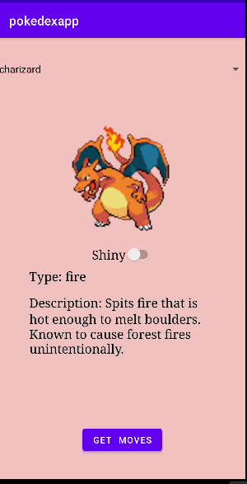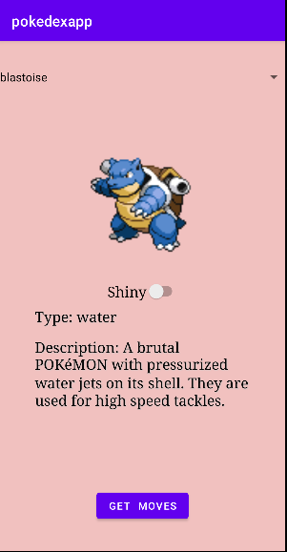

**Shiny Switch On**

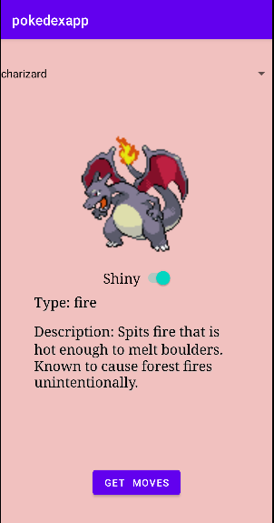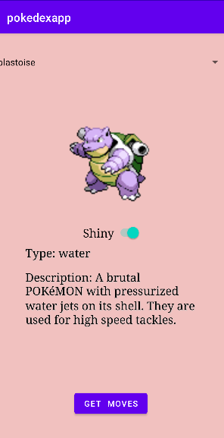

**Get Moves Button Pressed**

